## Definition of Game:

1. A game is the voluntary attempt to overcome unnecessary obstacles.

--1978 The Grasshopper, Bernard Suits

1. A game is a series of interesting decisions.

--Sid Meier

1. A closed, formal system that engages players in a structured conflict and resolves its uncertainty in an unequal outcome.

--Game Design Workshop, Tracy Fullerton

1. A game is a problem-solving activity, approached with a playful attitude.

--The Art of Game Design, Jesse Schell

1. A system of rules in which agents compete by making ambiguous, endogenously

meaningful decisions.

--Game Design Theory, Keith Burgun

6. 在电脑、手机或其它专用设备上运行的，具有目标和规则的娱乐形式，简称为游戏。

--Tsing Hua Mooc

7. 一种无目的的享乐行为，具有娱乐性，教育性以及艺术性。

## History of Game

第一世代 1972-1977 Odyssey (第一款商业化家用游戏主机), Telestar等

Pong第一款取得大规模商业成功的电子游戏

第二世代 1977-1983 Atari2600, ColecoVision, Odyssey 2

计算机技术突飞猛进的时代，八位处理器，可更换式游戏的设计

第三方游戏合法化，由于缺乏监管标准，导致大量垃圾游戏涌现（雅达利震，1982年12月发布的《吃豆人》《E.T.》品质拙劣导致滞销） 导致美国游戏产业萧条，家用市场向日本转移

第三世代 1983-1987 任天堂FC, 世嘉Master System

超级马里奥系列，魂斗罗，勇者斗恶龙等经典ip，完全转向日本市场

转折点，对未来产生深远影响

第四世代 1988-1994 任天堂Super FamiCom (本世代销量最高主机) 世嘉Mega Drive

十六位处理器，更丰富控制器设计，更出众图像表现效果

缺少重大变革，稳扎稳扎的完善和进步

第五世代 1993-1999 Jaguar, 3DO, Sega Satum, Play Station

2D向3D转变，光盘取代改变，PS取得巨大成功（最终幻想7）

变革的时代

第六世代 1999-2004 DreamCast, PS2, Xbox

主机性能大幅飞跃，游戏类型得到扩充——注重流畅体验和华丽演出的3D动作游戏《鬼泣》《战神》等

索尼是最大赢家，微软加入改变格局。家用主机最辉煌的年代

第七世代 2005-2013 Xbox360, PS3, Wii

三足鼎立，高清画面输出和网络服务

体感 （wii sport超越马里奥兄弟成为最畅销的游戏之一）

第八世代 2012至今 PS4, Xbox One, wii u

微软索尼都采用了x86架构

第九世代 2016至今 PS4 Pro, Xbox One X, Switch

技术创新与硬件升级快速迭代，任天堂继续追求创新

家用主机岌岌可危，掌机市场濒临灭绝，向手机平台转移

第十世代 ？？？ 云计算, 人工智能

## Common Frameworks to Ludology

**MDA:** mechanics, dynamics, and aesthetics

**Formal, dramatic, and dynamic elements**

**Elemental tetrad:** mechanics, aesthetics, story, and

Technology

### MDA:

**Mechanics:** The particular components of the game at the level of data representation and algorithms

**Dynamics:** The runtime behavior of the mechanics acting on player inputs and each other’s outputs over time

**Aesthetics:** The desirable emotional responses evoked in the player when she interacts with the game system

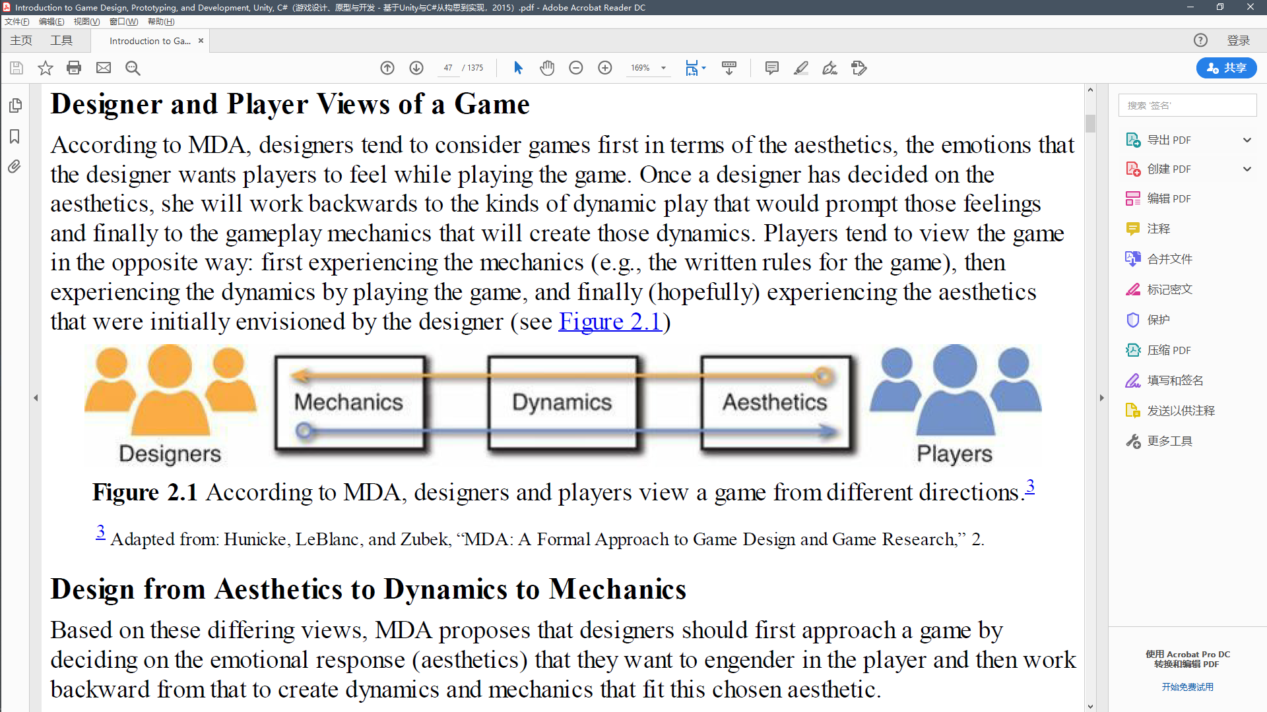

### Formal, dramatic, and dynamic elements:

* **Formal elements:** The elements that make games different from other forms of media or interaction and provide the structure of a game. Formal elements include things like rules, resources, and boundaries.

*Game Design Workshop* proposes seven formal elements of games:

**Player interaction pattern:** How do the players interact? Is the game single-player, one-on-one, team versus team, multilateral, unilateral, cooperative play, or even multiple individual players each working against the same system?

**Objective:** What are the players trying to achieve in the game? When has someone won the game?

**Rules:** Rules limit the players’ actions by telling them what they may and may not do in the game. Many rules are explicitly written and included in the game, but others are implicitly understood by all players (e.g., no rule says so, but it’s implicitly understood that you can’t steal money from the bank in *Monopoly*).

**Procedures:** The types of actions taken by the players in the game. A rule in *Snakes and Ladders* tells you to roll the die and move the number of spaces shown. The procedure dictatedby the rule is the actual action of rolling the die and moving the piece. Procedures are oftendefined by the interaction of a number of rules. Some are also outside of the rules: Though it isnot explicitly defined by the rules of poker, bluffing is an important procedure in the game.

**Resources:** Resources are elements that have value in the game. These include things like money, health, items, and property.

**Boundaries:** Where does the game end and reality begin? In his book *Homo Ludens*, Johan Huizinga introduces the term “magic circle” as one of several examples of a play-ground within which special rules apply. Katie Salen and Eric Zimmerman appropriated the term in their book

*Rules of Play* and further defined a magic circle as a temporary world where the rules of the game apply rather than the rules of the ordinary world. Their use of the term gave rise to its common use in the gaming community today. In a sport like football or ice hockey, the magic circle is defined by the boundaries of the playing field; but in an alternative reality game like *I* *Love Bees* (the ARG for *Halo 2*), the boundaries are more vague.

**Outcome:** How did the game end? There are both final and incremental outcomes in games. In a game of chess, the final outcome is that one player will win, and the other will lose. In a pen and paper roleplaying game like *Dungeons & Dragons*, there are incremental outcomes when a player defeats an enemy or gains a level, and even death is often not a final outcome since there are ways to resurrect players.

According to Fullerton, another way to look at formal elements is that the game ceases to exist when they are removed. If one removes the rules, outcome, or any of the others from a game, it really ceases to be a game.

* **Dramatic elements:** The story and narrative of the game, including the premise. Dramatic elements tie the game together, help players understand the rules, and encourage the player to become emotionally invested in the outcome of the game.

**Premise:** The basic story of the game world. In *Monopoly*, the premise is that each of the players is a real-estate developer trying to get a monopoly on corporate real estate in Atlantic City, New Jersey. In *Donkey Kong*, the player is trying to single-handedly save his girlfriend from a gorilla that has kidnapped her. The premise forms the basis around which the rest of the game’s narrative is built.

**Character:** Characters are the individuals around whom the story revolves, be it the nameless and largely undefined silent first-person protagonist of games like *Quake* or a character like Nathan Drake from the *Uncharted* series of games who is as deep and multidimensional as the lead characters in most movies. Unlike movies, where the goal of the director is to encourage the audience to have empathy for the film’s protagonist, in games, the player actually *is* the protagonist character, and designers must choose whether the protagonist will act as an avatar for the player (conveying the emotions, desires, and intentions of the player into the world of the game and following the wishes of the player) or as a role that the player must take on (so that instead the player acts out the wishes of the game character). The latter is the most common of the two and is much more straightforward to implement.

**Story:** The plot of the game. Story encompasses the actual narrative that takes place through the course of the game. The premise sets the stage on which the story takes place.

* **Dynamic elements:** The game in motion. Once players turn the rules into actual gameplay, the game has moved into dynamic elements. Dynamic elements include things like strategy, behavior, and relationships between game entities. It’s important to note that this is related to the use of the term *dynamics* in MDA but is broader because it includes more than just the runtime behavior of the mechanics.

**Emergence:** Collisions of seemingly simple rules can lead to unpredictable outcomes. Even an incredibly simplistic game like *Snakes and Ladders* can lead to unexpected dynamic experiences. If one player of the game happened to exclusively land on ladders throughout the game where another exclusively landed on snakes, each would have a very different experience of the game. If you consider the six additional proposed rules, it’s easy to imagine that the range

of gameplay experienced by players would expand in size due to the new rules (e.g., now, instead of fate being against player A, perhaps player B would choose to attack A at every possible opportunity, leading to a very negative play experience for A). Simple rules lead to complex and unpredictable behavior. One of a game designer’s most important jobs is to attempt to understand the emergent implications of the rules in a game.

**Emergent narrative:** In addition to the dynamic behavior of mechanics covered in the MDA model, Fullerton’s model recognizes that narrative can also be dynamic with a fantastic breadth of narratives emerging from the gameplay itself. Games, by their nature, put players in extranormal situations, and as a result, they can lead to interesting stories. This is the central appeal of pen and paper roleplaying games like *Dungeons & Dragons*, in which a single player acts as the Dungeon Master and crafts a scenario for the other players to experience and characters for

them to interact with. This is different from the embedded narrative covered by Fullerton’s dramatic elements and is one of the entertainment possibilities that is unique to interactive experiences.

**Playtesting is the only way to understand dynamics:** Experienced game designers can often make better predictions about dynamic behavior and emergence than novice designers, but no one understands exactly how the dynamics of a game will play out without playtesting them. The six additional rules proposed for *Snakes and Ladders* seem like they would increase strategic

play, but it is only through several rounds of playtests that one could determine the real effect the rules changes would have on the game. Repeated playtesting reveals information about the various dynamic behaviors that a game could have and helps designers understand the range of experiences that could be generated by their game.

## The Layered Tetrad

**Mechanics:** The rules for interaction between the player and the game. Mechanics are the elements in the tetrad that differentiate games from all noninteractive forms of media (like film or books). Mechanics contain things like rules, objectives, and the other formal elements described by Fullerton. This is different from the *mechanics* presented by MDA because Schell’s use of the term differentiates between game mechanics and the underlying technology that enables them.

**Aesthetics:** Aesthetics describe how the game is perceived by the five senses: vision, sound, smell, taste, and touch. Aesthetics cover everything from the soundtrack of the game to the character models, packaging, and cover art. This is different from MDA’s use of the word *aesthetics* because MDA used the word to refer to the emotional response engendered by the game, while Schell uses the word to refer to things that are crafted by the game developers like actual game art and sound.

**Technology:** This element covers all the underlying technology that makes the game work. While this most obviously refers to things such as console hardware, computer software, rendering pipelines, and such, it also covers technological elements in board games. Technology in board games can include things like the type and number of dice that are chosen, whether dice or a deck of cards are used as a randomizer, and various stats and tables used to determine the outcome of actions. In fact, the Technology Award at the IndieCade game conference in 2012 went to Zac S. for *Vornheim*, a collection of tools—in the form of a printed book—to be used by game masters when running tabletop roleplaying games set in a city.99 http://www.indiecade.com/2012/award_winners/.

**Story:** Schell uses the term story to convey everything covered by Fullerton’s dramatic elements, not just what she terms *story*. *Story* is the narrative that occurs in your game and includes both premise and characters as well.

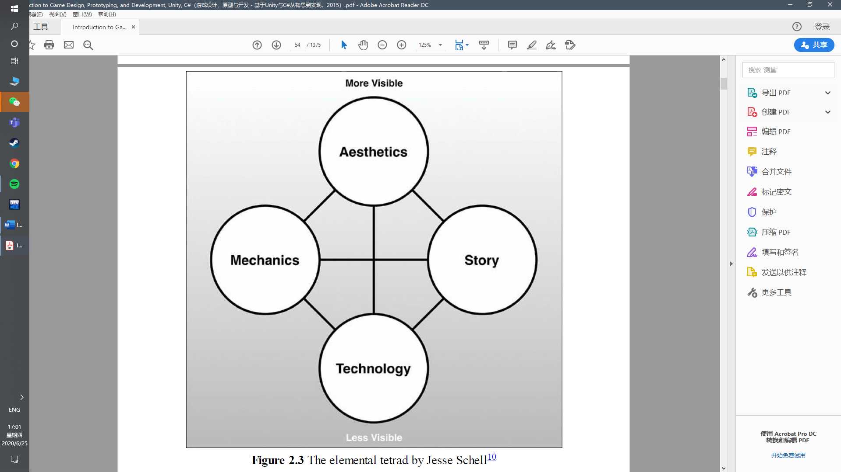

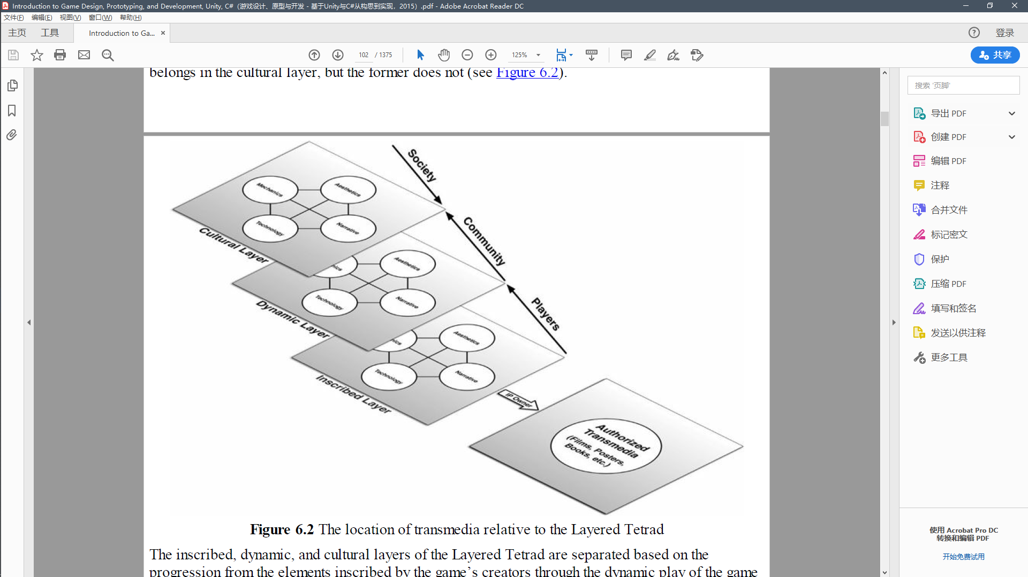

## Acting like a Designer

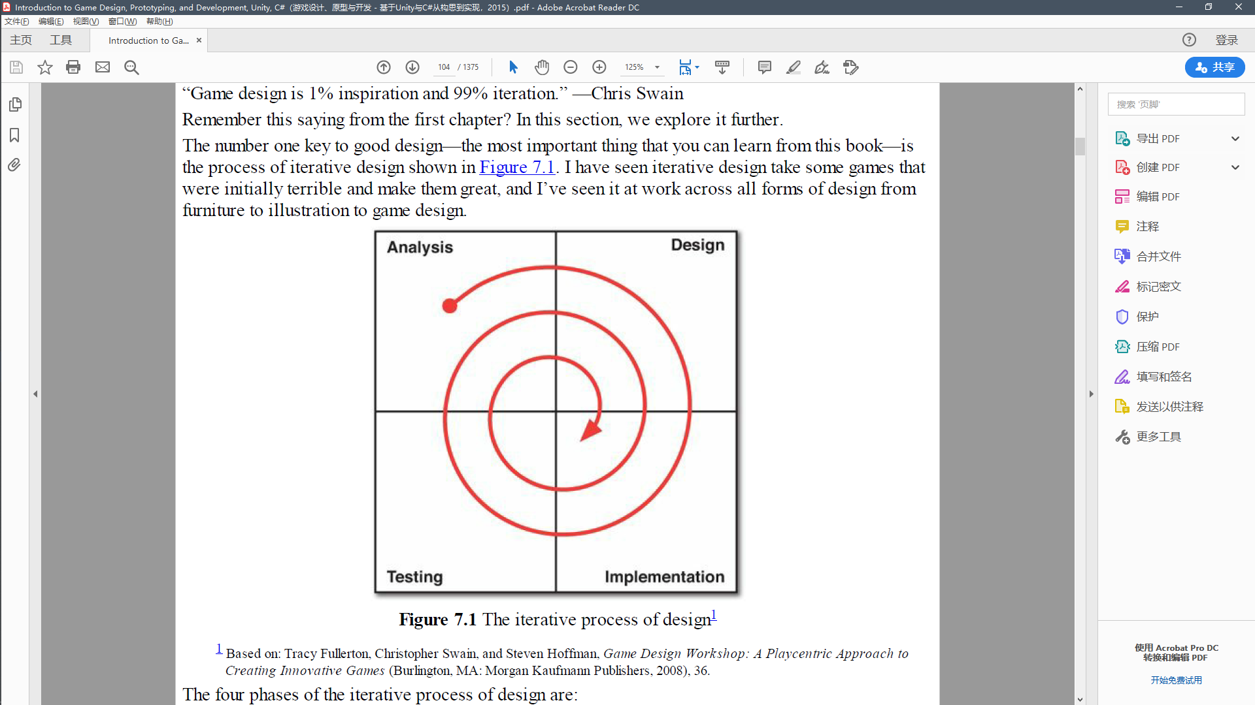

### Analysis

**1. For whom am I designing the game?**

**2. What are my resources?**

**3. What prior art exists?**

**4. What is the fastest path to a playable game that demonstrates what I want to test?**

### Design

**Listen to your audience**

**Listen to your team**

**Listen to your client**

**Listen to your game**

**Listen to yourself**

**Listen to your gut**

**Listen to your health**

**Listen to how you sound to other people**

## Implementation

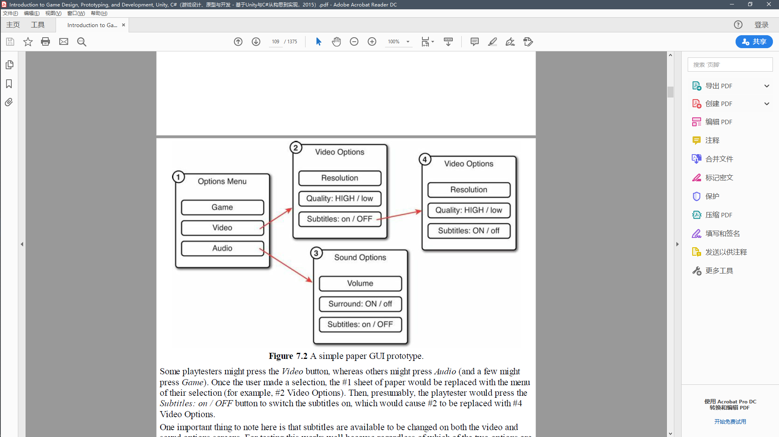

## Testing

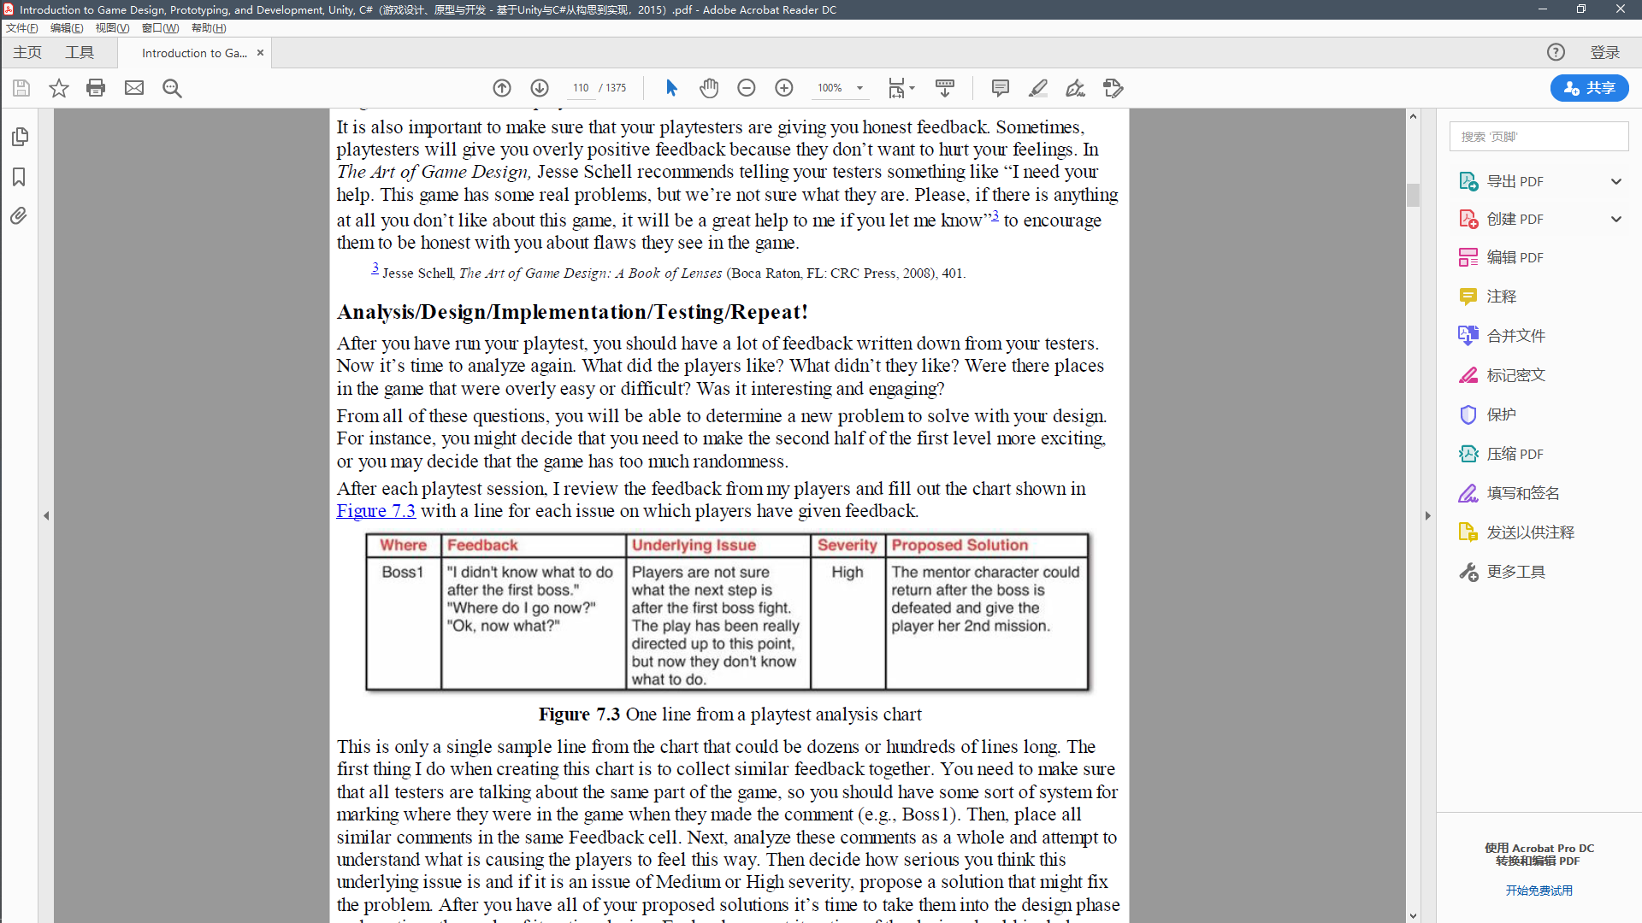

## Innovation:

“In his book *The Medici Effect,*4 author Frans Johansson writes about two kinds of innovation: incremental and intersectional.”

“The best way to have a good idea is to have a lot of ideas and throw out all the bad ones.” —Linus Pauling

## Design Goals

### Designer-Centric

**Fortune:** You want to make money.

**Fame:** You want people to know who you are.

**Community:** You want to be part of something.

**Personal expression:** You want to communicate with others through games.

**Greater good:** You want to make the world better in some way.

**Serious games:** This is one of the oldest and most general names for games of this type. These

games can of course still be fun; the “serious” moniker is just to note that there is a purpose

behind the game that is more than just playful. One common example of this category is

educational games.

**Games for social change:** This category of games for good is typically used to encompass

games that are meant to influence people or change their minds about a topic. Games about

things like global warming, government budget deficits, or the virtues or vices of various

political candidates would fall into this category.

**Games for behavioral change:** The intent of these games is not to change the mind or opinion

of the player (as in games for social change) but instead to change a player’s behavior outside

of the game. For example, many medicinal games have been created to discourage childhood

obesity, improve attention spans, combat depression, and detect things like childhood

amblyopia. There is a large and growing amount of research out there demonstrating that games

and game play can have significant effects (both positive and negative) on mental and physical

health.

**Becoming a better designer:** You simply want to make games and improve your craft.

### Player-Centric

**Fun:** You want players to enjoy your game.

**Enjoyable:** There are many ways for something to be enjoyable, and enjoyment in one form or

another is what most players are seeking when they approach a game.

**Agon**: Competitive play (e.g., chess, baseball, *Uncharted*)

**Alea**: Chance-based play (e.g., gambling and rock, paper, scissors)

**Ilinx**: Vertiginous play (e.g., roller coasters, children spinning around until they’re dizzy, and

other play that makes the player feel vertigo)

**Mimicry**: Play centered on make-believe and simulation (e.g., playing house, playing with

action figures)

Each of these kinds of play are enjoyable in their own way, and as Chris Bateman points out in

his book *Imaginary Games,* a fine line exists between excitement and fear in games of ilinx, the

only difference being the lusory attitude of the player.3

**Engaging:** The game must grab and hold the player’s attention. In his 2012 talk, “Attention, Not

Immersion,” at the Game Developers Conference in San Francisco, Richard Lemarchand, colead

game designer of the *Uncharted* series of games, referred to this as “attention,” and it’s a

very important aspect of game design. I discuss his talk in greater detail later in this chapter.

**Fulfilling:** Playing the game must fill some need or desire of the player. As humans, we have

many needs that can be met through play in both real and virtual ways. The need for

socialization and community, for instance, can be met both through playing a board game with

friends or experiencing the day-to-day life of *Animal Crossing* with the virtual friends who live

in your town. The feeling of *fiero* (the Italian word for personal triumph over adversity)4 can be

achieved by helping your team win a soccer match, defeating a friend in a fighting game like

*Tekken*,5 or by eventually defeating the final level in a difficult rhythm game like *Osu! Tatake!*

*Ouendan*. Different players have different needs, and the same player can have drastically

different needs from day to day.

**Lusory attitude:** You want players to take part in the fantasy of your game.

**Flow:** You want players to be optimally challenged. 心流

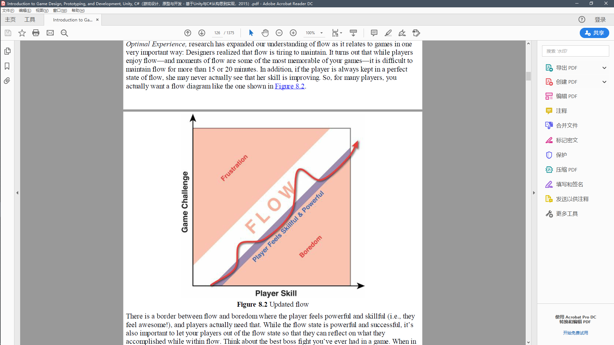

**Structured conflict:** You want to give players a way to combat others or challenge your game systems.

**Empowerment:** You want players to feel powerful both in the game and in the metagame.

**Autotelic 内在动力**

**Performative**

**Attention and Involvement**

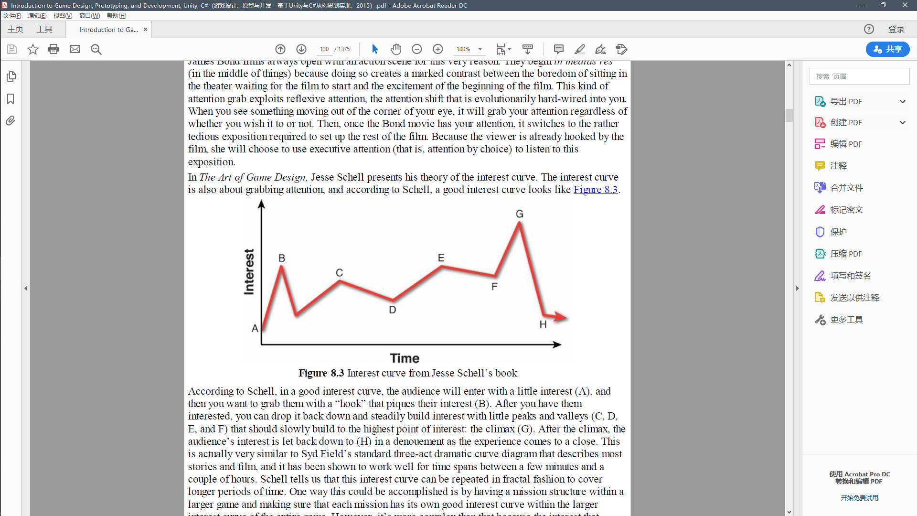

反差

**Interest/attention/involvement:** You want players to be engaged by your game.

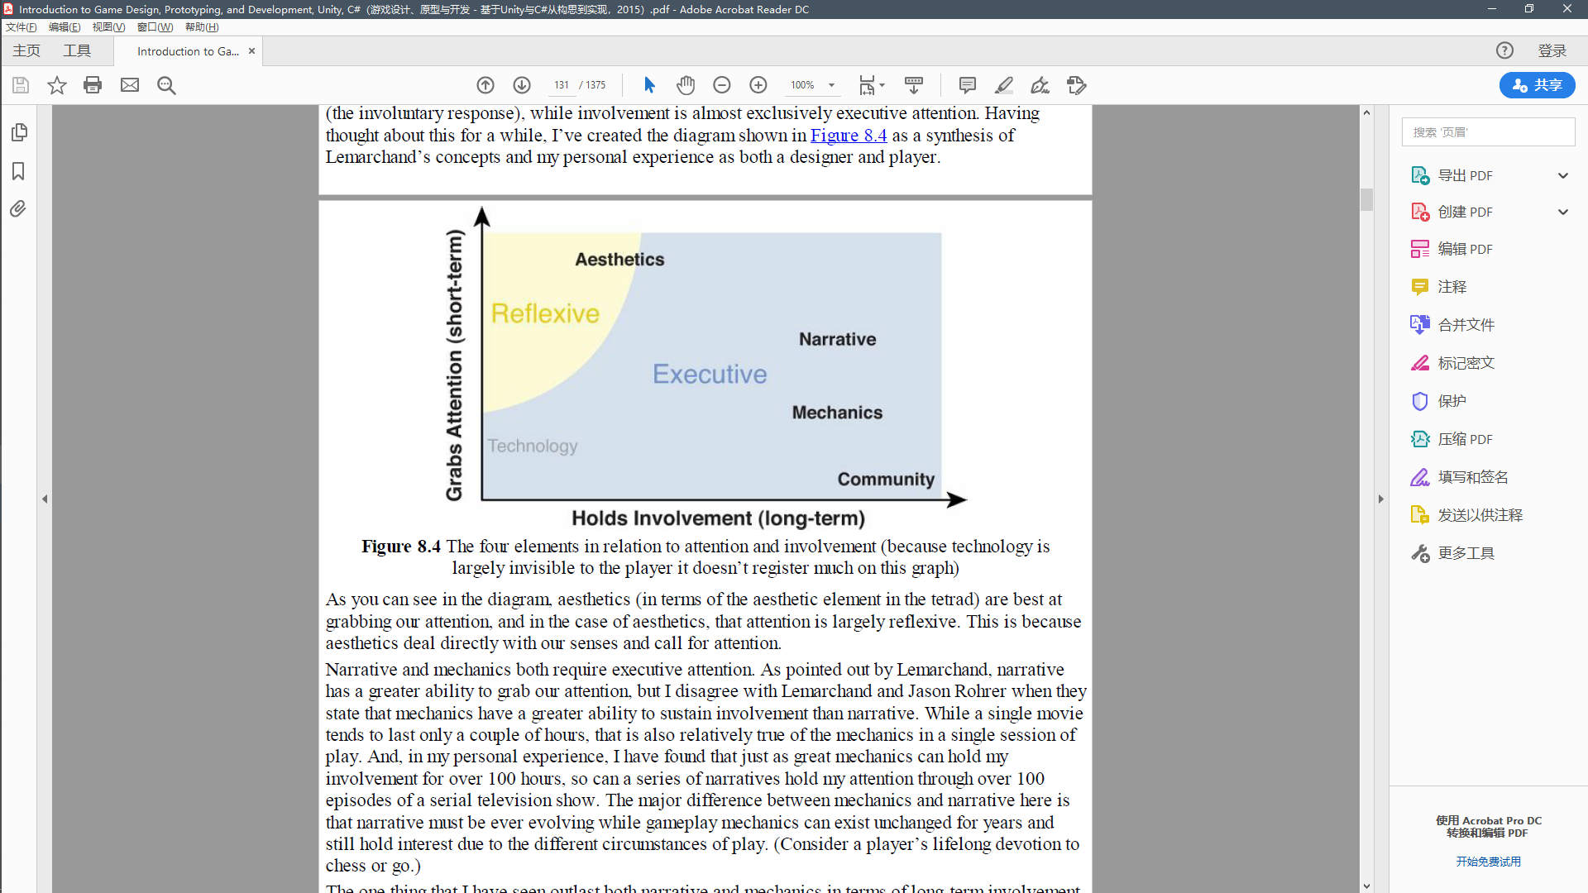

**Meaningful decisions:** You want players’ choices to have meaning to them and the game. To be meaningful, a decision must be both ***discernible*** and ***integrated***:

**Discernible:** The player must be able to tell that the game received and understood her decision

(i.e., immediate feedback).

**Integrated:** The player must believe that her decision will have some effect on the long-term

outcome of the game (i.e., long-term impact)

**Ambiguous:** A decision is ambiguous for the player if she can guess at how it might affect the

system but can never be sure. The decision to wager money in the stock market is ambiguous.

As a savvy investor, you should have a pretty decent guess about whether the value of the stock will go up or down, but the market is so volatile that you can never know for sure.

**Double-edged:** A decision is double-edged when it has both an upside and a downside. In the

previous stock purchase example, the upside is the longer-term potential to make money, and the

downside is the immediate loss of the resource (money) used to purchase the stock as well as the potential for the stock to lose value

**Novel:** A decision is novel if it is sufficiently different from other decisions that the player has

made recently. In the classic Japanese roleplaying game (JRPG) *Final Fantasy VII*, combat

with a specific enemy changes little once the encounter has begun. If the enemy is weak to fire, and the player has enough mana and fire magic, she will generally attack every round with fire magic until the enemy is defeated. In contrast, the excellent combat in the JRPG *Grandia III* makes positioning and location important for most special attacks but the player’s characters

move around the field independent of player input. Whenever the player is able to make a

decision, time freezes for her, and she must reevaluate the positions of allies and enemies

before making each decision. This movement of her characters and the importance of position

make every combat decision novel.

**Clear** A choice can be unclear if there are too many options to choose from at a given time. A choice can be unclear if the player can’t intuit the likely outcome of the choice. A choice can also be unclear if the player doesn’t understand the significance of the choice.

**Experiential understanding:** You want players to gain understanding through play.

## Positive and Negative Feedback

Super Mario Kart & Monoply

Be careful of using positive feedback in Multiplayer game